Early Childhood
Education & Family Studies Portfolio Handbook
2018-2019

Early Childhood Education & Family Studies Portfolio Handbook
2017-2018
Table of Contents:
Program Outcomes 2
Portfolio Overview 3
NAEYC Standards/Course Alignment 4
Portfolio Content 6
Artifact Cover Sheet 8
Frequently Asked Questions 9
Program Contact Information 11

MISSION STATEMENT
Early Childhood Education & Family Studies Portfolio Handbook
Providing educators of young children with a solid foundation of knowledge in child development, instructional strategies, and Oregon Core Body of Knowledge (OCBK) for pre-natal through grade 3 in alignment to the National Association for the
Education of Young 1
Children (NAEYC) standards.

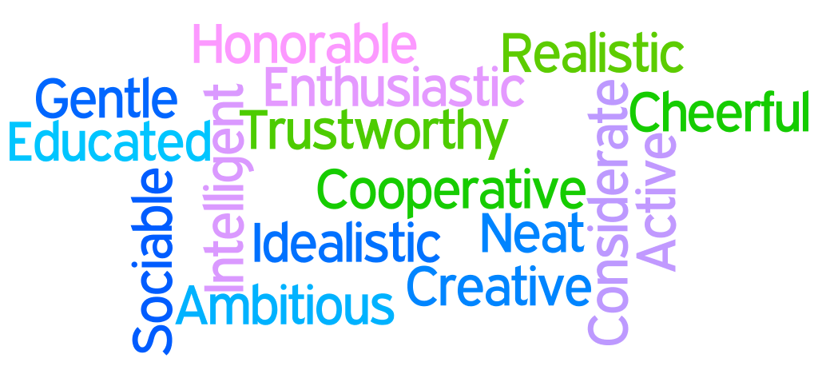

PROGRAM OUTCOMES:
The Early Childhood Education and Family Studies (ECE & FS) department prepares you for State Certification in Early Childhood Education. Courses can be used to fulfill training and education requirements for family child care providers and child care teachers in Oregon.
Based on recommendations from the National Association for the Education of Young Children (NAEYC) for Associate-level preparation for Early Childhood Professionals, CGCC’s Early Childhood Education and Family Studies (ECE & FS) program prepares students to:
Early Childhood Education & Family Studies Portfolio Handbook

- Use their understanding of young children’s characteristics and needs, and of the multiple interacting influences on children’s development and learning, to create environments that are healthy, respectful, supportive, and challenging for all children.
- Apply a recognition of the importance and complex characteristics of children’s families and communities to the creation of respectful reciprocal relationships that support and empower families and involve all families in their children’s development and learning.

- Use systematic observation, documentation, and other effective assessment strategies in a responsible way, in partnership with families and other professionals, to positively influence children's development and learning.

- Employ their understanding of and relationships with children and families and their understanding of developmentally and culturally effective approaches to teaching and learning to implement and evaluate experiences that promote positive development and learning for all young children.

- Identify and conduct themselves as members of the early childhood profession.

- Use ethical guidelines and other professional standards related to early childhood practice.

- Identify themselves as continuous, collaborative learners who demonstrate knowledgeable, reflective, and critical perspectives on their work, making informed decisions that integrate knowledge from a variety of sources.

- Act as informed advocates for sound educational practices and policies.
2
Early education classes meet state continuing education requirements for teachers and family child care providers.

3

PORTFOLIO OVERVIEW:
Each student in the Associates of Applied Science (AAS) degree Early Childhood Education & Family Studies (ECE & FS) program will prepare a portfolio.

The portfolio is a collection of student work (artifacts) that demonstrates the student’s growth over time as an early childhood educator. The portfolio defines and identifies what an emerging teacher knows and the areas in which s/he is still developing. The portfolio reveals the student's ability to think critically by connecting the student's work to the standards set forth by the National Association for the Education of Young Children (NAEYC). It also is documentation of the student's ability to see the interrelatedness of the core courses of the Early Childhood Education & Family Studies Program.
Early Childhood Education & Family Studies Portfolio Handbook

The student learns this interrelatedness through developing an educational philosophy and collecting artifacts and reflections from the core courses. A significant component of the portfolio is the artifact and reflection section. Each artifact will be accompanied by a reflection. The artifacts can be prepared as assignments in each course, prepared independently by the student or a combination of both; the reflections will be submitted at the end of each course.

This handbook provides an in depth explanation of each of the portfolio components.

NAEYC STANDARDS
Early Childhood Education & Family Studies Portfolio Handbook

( 4 )

Early Childhood Education & Family Studies Portfolio Handbook
NAEYC Standard | DESCRIPTION
Standard 1. Promoting Child Development and Learning | Candidates prepared in early childhood degree programs are grounded in a child development knowledge base. They use their understanding of young children’s characteristics and needs, and of multiple interacting influences on children’s development and learning, to create environments that are healthy, respectful, supportive, and  challenging for each child.
Standard 2. Building Family and Community Relationships | Candidates prepared in early childhood degree programs understand that successful early childhood education depends upon partnerships with children’s families and communities. They know about, understand, and value the importance and complex characteristics of children’s families and communities. They use this understanding to create respectful, reciprocal relationships that support and empower families, and to involve all families in  their children’s development and learning.
Standard 3. Observing, Documenting and Assessing to Support Young Children and Families | Candidates prepared in early childhood degree programs understand that child observation, documentation, and other forms of assessment are central to the practice of all early childhood professionals. They know about and understand the goals, benefits, and uses of assessment. They know about and use systematic observations, documentation, and other effective assessment strategies in a responsible way, in partnership with families and other professionals, to positively influence the development of every child.
Standard 4. Using Developmentally Effective Approaches | Candidates prepared in early childhood degree programs understand that teaching and learning with young children is a complex enterprise, and its details vary depending on children’s ages, characteristics, and the settings within which teaching and learning occur. They understand and use positive relationships and supportive interactions as the foundation for their work with young children and families. Candidates know,  understand, and use a wide array of developmentally appropriate approaches, instructional strategies, and tools to connect with children and families and positively influence each child’s development and learning.
Standard 5. Using Content Knowledge to Build Meaningful Curriculum | Candidates prepared in early childhood degree programs use their knowledge of academic disciplines to design, implement, and evaluate experiences that promote positive development and learning for each and every young child. Candidates understand the importance of developmental domains and academic (or content) disciplines in  early childhood curriculum. They know the essential concepts, inquiry tools, and structure of content areas, including academic subjects, and can identify resources to deepen their understanding. Candidates use their own knowledge and other resources to design, implement, and evaluate meaningful, challenging curriculum that promotes comprehensive developmental and learning outcomes for every young child.
Standard 6. Becoming a Professional | Candidates prepared in early childhood degree programs identify and conduct themselves as members of the early childhood profession. They know and use ethical guidelines and other professional standards related to early childhood practice. They are continuous, collaborative learners who demonstrate knowledgeable, reflective and critical perspectives on their work, making informed decisions that integrate knowledge from a variety of sources. They are informed advocates for sound educational practices and policies.
Standard 7. Early Childhood Field Experiences  ( 5 ) | Field experiences and clinical practice are planned and sequenced so that candidates develop the knowledge, skills and professional dispositions necessary to promote the development and learning of young children across the entire developmental period of early childhood – in at least two of the three early childhood age groups (birth–age 3, 3 through 5, 5 through 8 years) and in the variety of settings that offer early education (early school grades, child care centers and homes, Head Start programs).
Early Childhood Education & Family Studies Portfolio Handbook
4

6

PORTFOLIO CONTENT

- Title Page
  - Contact info, including your name, address, phone number, and email address

- Table of Contents
  - Clear organization.
Early Childhood Education & Family Studies Portfolio Handbook

- Introduction to your portfolio (1 page)
  - Discuss your educational history (full time or part time CGCC student, transfer student, adult learner, new career, etc.)

  - Explain the organization of your portfolio

- Resume (1-2 pages)

- Philosophy & Beliefs Statement (1-2 pages)

- Permission to use or publish (if applicable)
If your portfolio contains pictures of children or documents that are child or
center specific you must include a signed/dated permission slip from the
parent or authorized guardian.

- Artifacts and Reflections
  - 14 Artifacts and Reflections total (one artifact with a reflection for
each core course in the program, plus one elective)

  - Align each NAYEC standard (a total of 7) to two artifacts and reflections

  - Each ECE&FS core course, plus one elective will be represented with one artifact and reflection
  - Each NAYEC standard will be represented with two artifacts and reflections

- Practicum Summary
  - The student will write a 2-3 page summary discussing her/his practicum experience and growth
- Closing Statement5
  - ECE 200 portfolio documents will be helpful in preparing your
closing statement

- Summary
  - The student will write a 2-3 page summary of her/his ECE & FS learning experience at CGCC

  - Focal points for the summary:

    - How CGCC’s ECE & FS Degree Program has changed your early childhood practice
Early Childhood Education & Family Studies Portfolio Handbook

    - The growth you have seen in yourself as a professional

    - The experiences at CGCC that were most influential in your growth

    - Your goals as you move forward in your career as an early childhood educator

    - Your thoughts on the portfolio process

  - You may include interviews, photos, audio clips, children's creations, or any other documentation that depicts your professional development

7

ARTIFACT COVER SHEET
It will be very helpful for you to print this cover sheet and take it to your ECE & FS core classes. Your instructors can help you identify artifacts from each of your core classes.
Early Childhood Education & Family Studies Portfolio Handbook

NAME: SID #:

ECE COURSE:
ECE INSTRUCTOR:
NAEYC STANDARD BEING MET:

INSTRUCTOR COMMENTS:

Instructor’s Signature Date

Columbia Gorge Community College is an equal opportunity educator and employer. If you need 8
information regarding accommodations for a disability please contact Shayna Dahl, Disability Resources Advisor at 541-506-6046 or via email sdahl@cgcc.edu

9

FREQUENTLY ASKED QUESTIONS
- What is the Early Childhood Education & Family Studies portfolio? The ECE & FS portfolio is documentation of the growth in your knowledge and thinking during your course of study at CGCC. The portfolio is organized in a manner that provides clear evidence of your growth. In essence, the portfolio is the story of your experiences and reflections on the field of Early Childhood Education.
Early Childhood Education & Family Studies Portfolio Handbook

- What is an artifact?
An artifact is a major assignment from a core course in the ECE & FS program. It should be an assignment that was particularly meaningful to you. It cannot be a reflection or journal entry. An artifact may also be a lesson or activity you have done in your work with young children and families.

- How many artifacts must I include in my portfolio?
You will need to include 14 artifacts, a minimum of one from each of the core courses in the ECE & FS program, plus one elective.

- How will I select my artifact?
Your artifact should be an assignment that was particularly meaningful to you, though it cannot be solely a reflection or a journal entry. You will need an artifact for each of the seven NAEYC standards (see p. 4). Select two artifacts that you feel strongly represents a particular standard. Your instructors can guide you in the selection process.

- Where can I find the NAEYC standards?
The NAEYC standards can be found in this handbook on p. 4 and 5. Your practicum instructor has also prepared a portfolio template that contains the standards. Several of your textbooks will have the standards in them.

10
- What is a reflection?
A reflection is your personal statement about your work. This is your opportunity to think about your work in a particular course with your artifact as the culminating experience. Your reflection should:
Early Childhood Education & Family Studies Portfolio Handbook
  - Explain the connection between the artifact and the NAEYC standard
  - Discuss what the standard means to you - why you selected it
  - Compare your thinking before you took the course and after you took the course.
  - Chapter 10 of “To Teach Well” has information to guide you in writing a reflection.

- What is the detailed process for portfolio submissions?
Artifacts are completed in each course.
  - Reflections are due at the end of each course. You will submit your reflection to your Instructor. Your instructor will score your reflection and return it to you. Your Instructors will also guide you in selecting your artifacts.
  - The Portfolio with 14 artifacts and 14 reflections is due at the end of ECE 260B/265 (spring term, second year).
  - A presentation event will occur at the end of ECE 260B/265. You will have the opportunity to share your portfolio, answer questions about your portfolio, and celebrate your work with colleagues and CGCC faculty.

- I transferred to CGCC from another college. Will I still need to follow the same portfolio process?
As a transfer student, you will still need to complete a portfolio. Work
with your ECE & FS instructors to assist you in the process.

11

Program Contact Information

ECE & FS Practicum Instructor
Early Childhood Education & Family Studies Portfolio Handbook
Eliza Greenway
egreenway@cgcc.edu

ECE & FS Department Chair
TBD

ECE & FS Academic Advisor
Kelly Sullivan
541-506-6022
kmsullivan@cgcc.edu

Student Support Services Coordinator
Disability Resources, Mental Health, PASS Program
Shayna Dahl
541-506-6046
sdahl@cgcc.edu

ECE & FS website http://www.cgcc.edu/career-tech-ed/early-ed

Columbia Gorge Community College is an equal opportunity educator and employer. If you need
information regarding accommodations for a disability please contact Shayna Dahl, Disability Resources Advisor at 541-506-6046 or via email sdahl@cgcc.edu

